T-Shirt

1. Ted The Stoner: Ruff Day

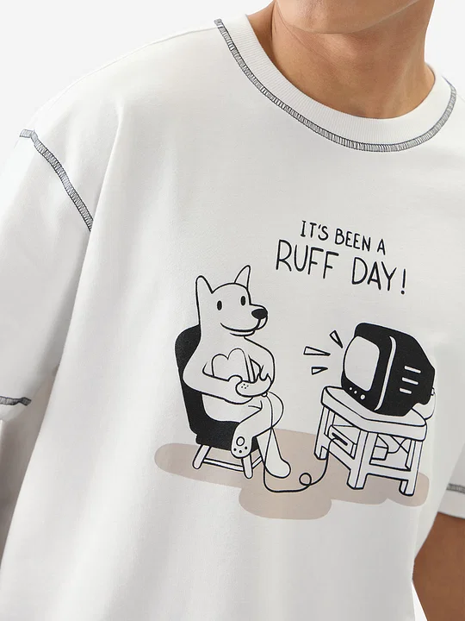 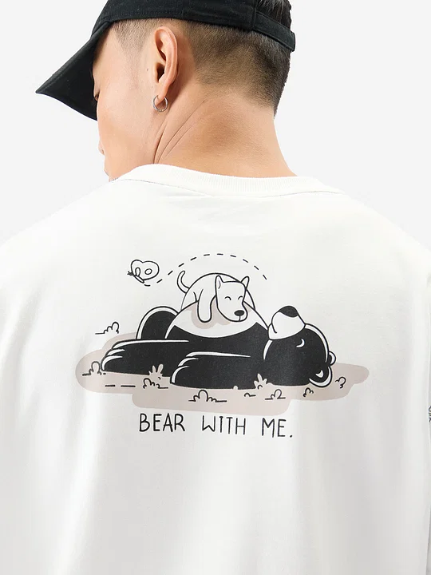 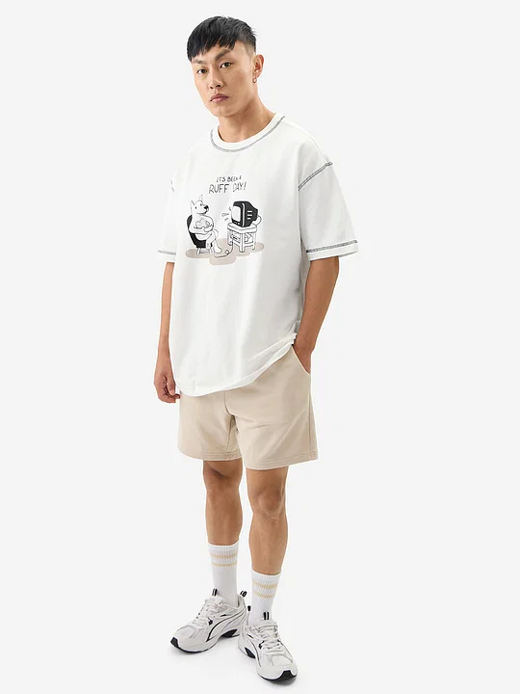

Link: <https://res.cloudinary.com/dvyft9plf/image/upload/v1725693080/1_oversized_1_dd0kpz.webp>

* + Description
    - Blaze through life (responsibly) with our Ted the Stoner tee. These oversized t-shirts make you feel comfy while you stand out in the crowd. The loose, relaxed fit is perfect for those who love a laid-back vibe without compromising on style.
    - Style Tip: Let your personality shine by pairing these tees with your favorite denim, joggers, or shorts. Mix and match with confidence, and don't be afraid to experiment with different patterns for a truly unique look.
  + Material & Care:
    - Premium Heavy Gauge Fabric
    - 100% Cotton
    - Machine Wash

1. Anitique Red

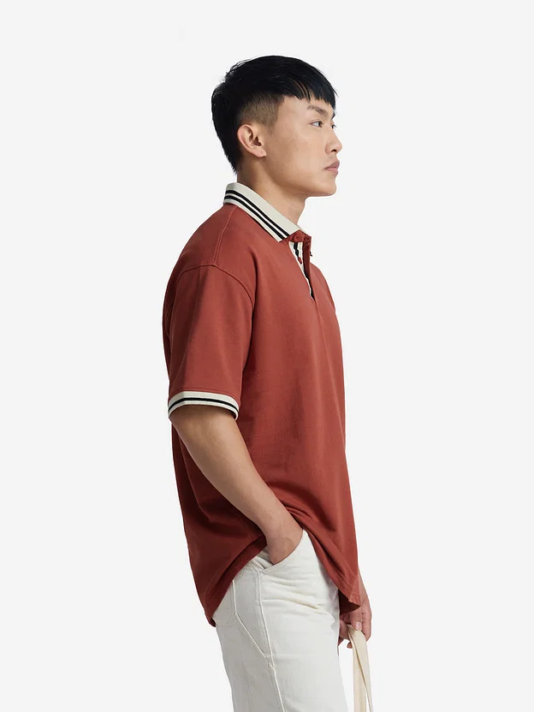 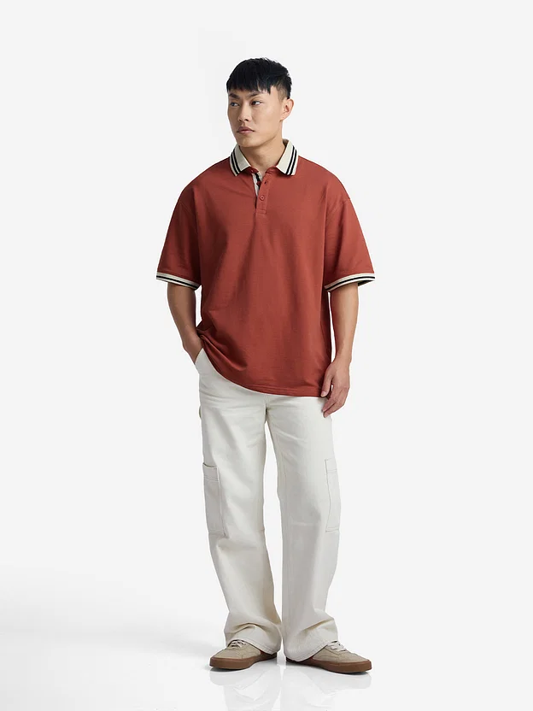 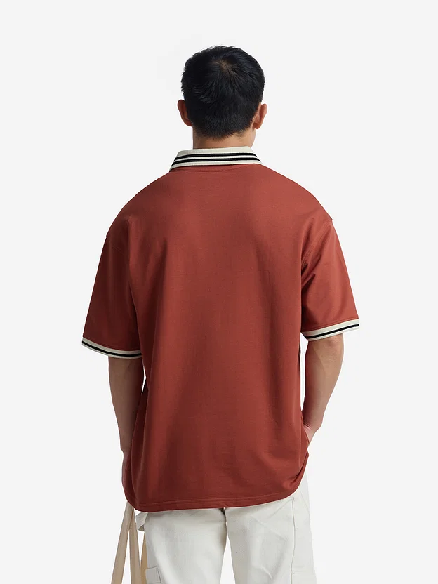

Link: <https://res.cloudinary.com/dvyft9plf/image/upload/v1725693080/Polo_1_ekvj5p.webp>

* + Description
    - Shop for TSS Originals: Antique Red Oversized Polos at The Souled Store.
  + Material & Care:
    - Premium Heavy Gauge Fabric
    - 100% Cotton
    - Machine Wash

1. Daffy Duck: Allergic To Idiots

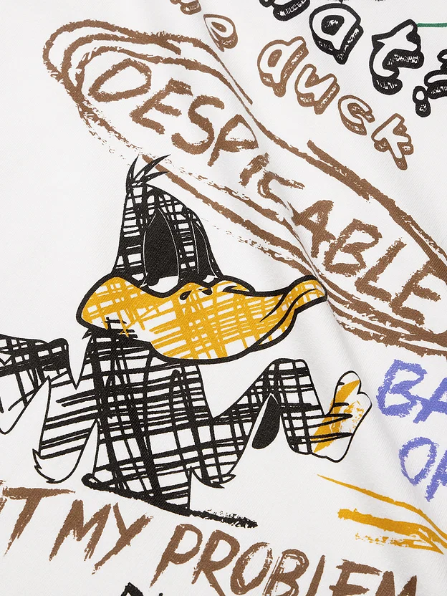 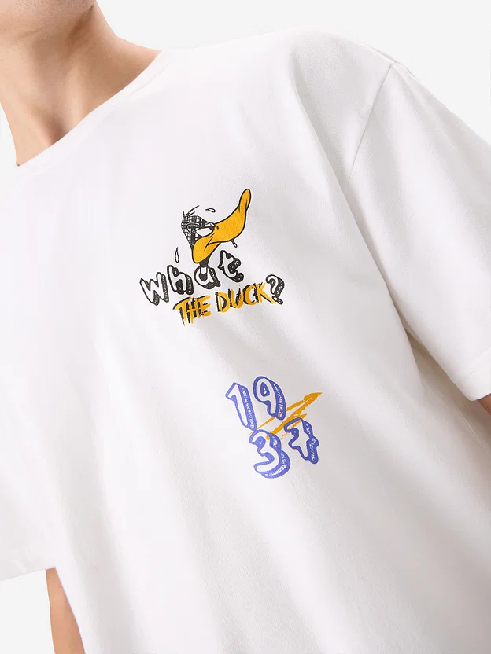 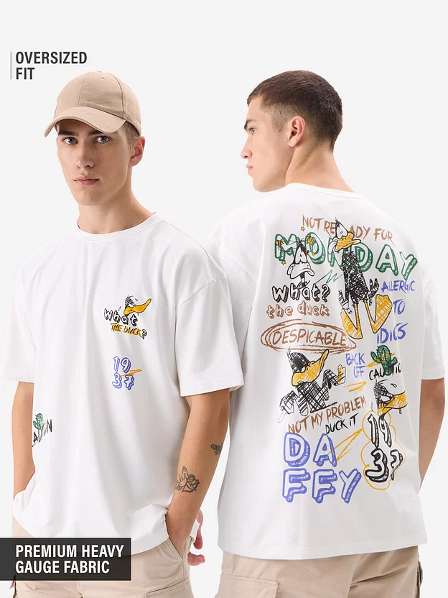

Link: <https://res.cloudinary.com/dvyft9plf/image/upload/v1725693081/Square_neck_1_eik8ot.webp>

* + Description
    - Like to throw temper tantrums while shouting "Despicable me!"? Then this tee is for you! Designed for those who appreciate lounging around in style, these tees are a wardrobe essential. Perfect for any occasion, from casual outings to chilling at home, these tees are your new go-to's.
    - Style Tip: Pair these tees with slim-fit bottoms for a balanced look. Throw on a denim jacket or layer with accessories to enhance your street-style appeal. Whether you pair them with jeans, shorts, or joggers, these tees effortlessly complement any style.
  + Material & Care:
    - Premium Heavy Gauge Fabric
    - 100% Cotton
    - Machine Wash

Jeans

**Description**

1. Denim: Granite Grey (Straight Fit)

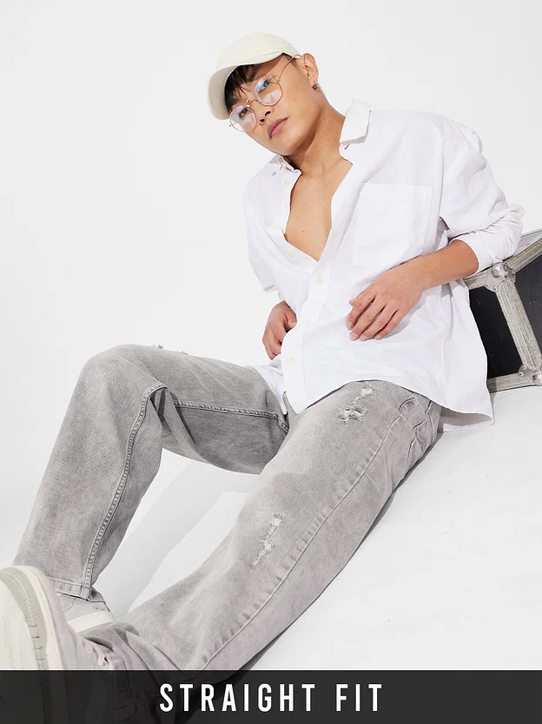 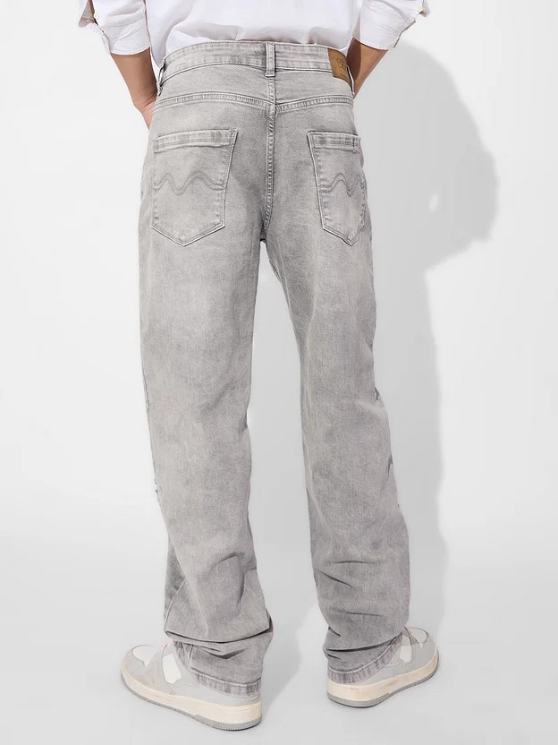 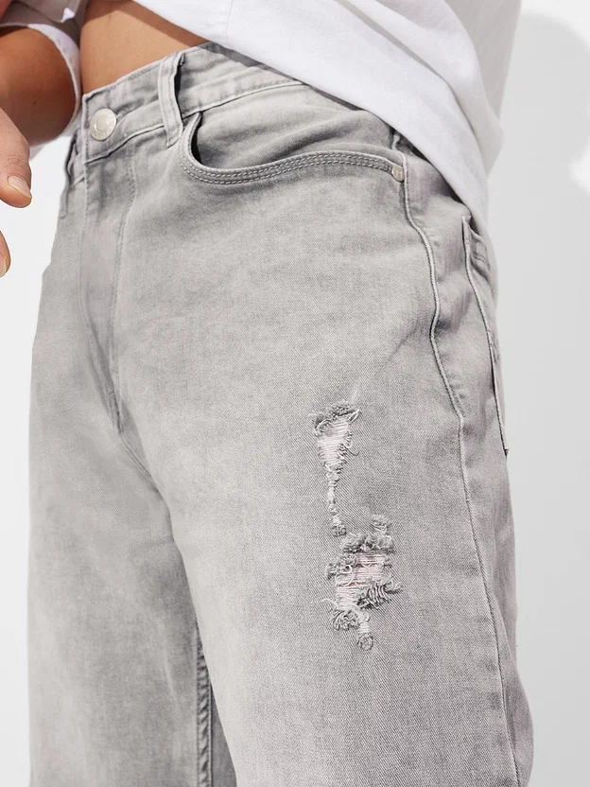

Link: <https://res.cloudinary.com/dvyft9plf/image/upload/v1725693097/Straight_fit_1_jnrzcc.webp>

* + Description
    - Step up your denim game with our classic straight fit jeans. Versatile and timeless, these jeans offer a sleek silhouette that effortlessly transitions from day to night.
    - Style Tip: Dress them up with a crisp button-down shirt and loafers for a polished look. Keep it casual by pairing them with a tee and sneakers for weekend adventures.
  + Material & Care:
    - 98% Cotton 2% Spandex
    - Machine Wash

1. Denim: Beige (Baggy Fit)

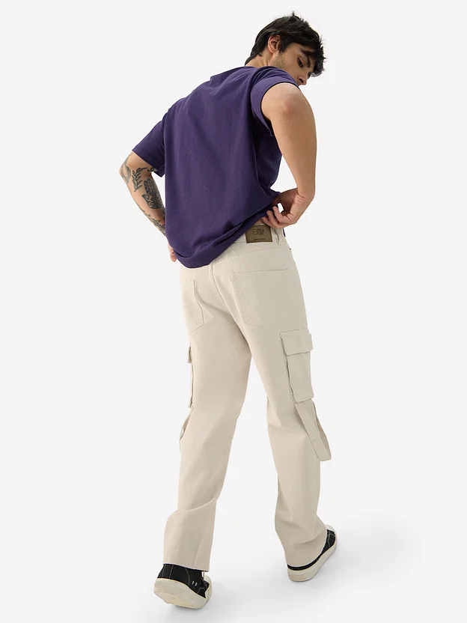 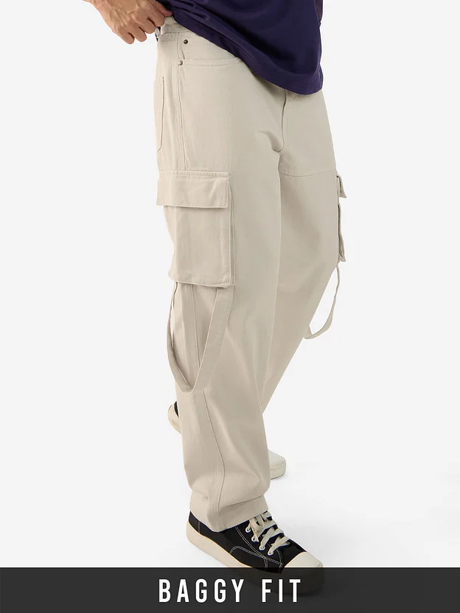 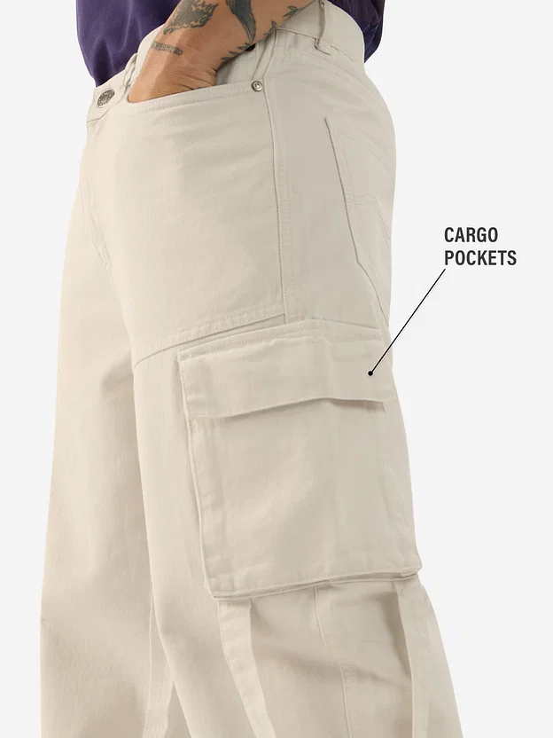

Link: <https://res.cloudinary.com/dvyft9plf/image/upload/v1725693096/beige_baggy_1_ao1nae.webp>

* + Description
    - Men Cargo Jeans
    - Chill in relaxed style with our trendy baggy fit jeans. Designed for comfort without sacrificing style, these jeans are perfect for those who prefer a more relaxed silhouette.
    - Style Tip: Balance the loose fit with a fitted tee and sneakers for a modern streetwear look. Add a denim jacket and boots for a rugged and effortlessly cool outfit.
  + Material & Care:
    - 100% Cotton
    - Machine Wash

1. Baggy Fit

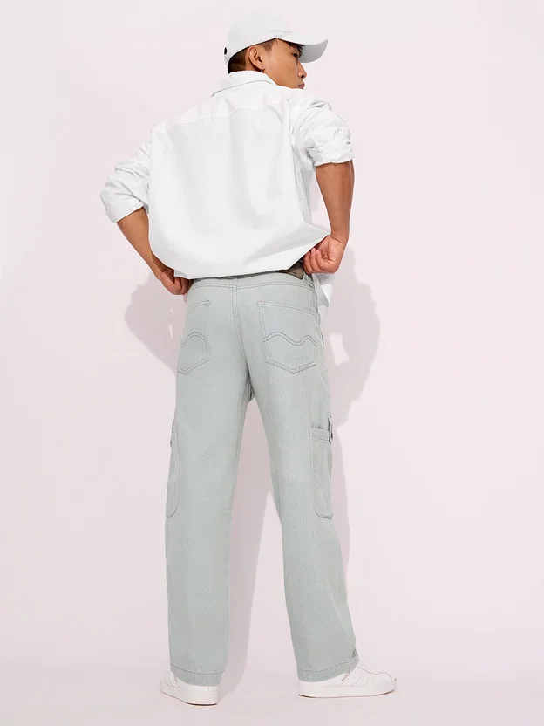 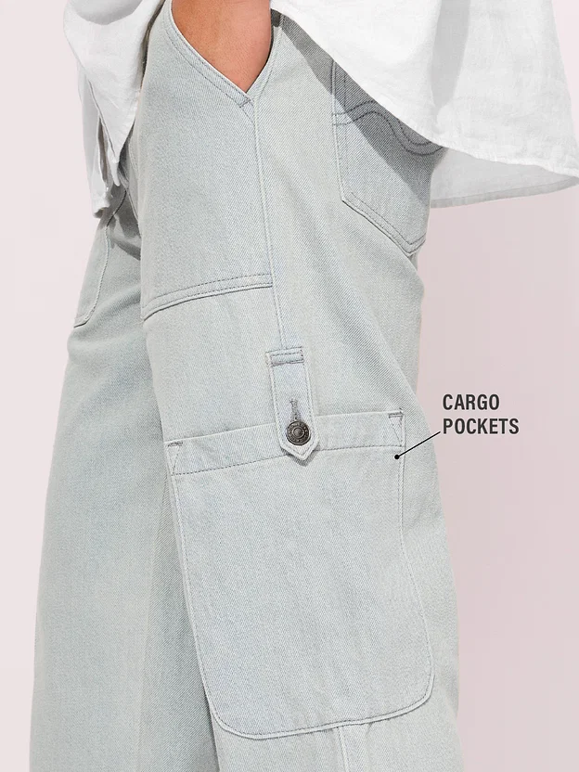 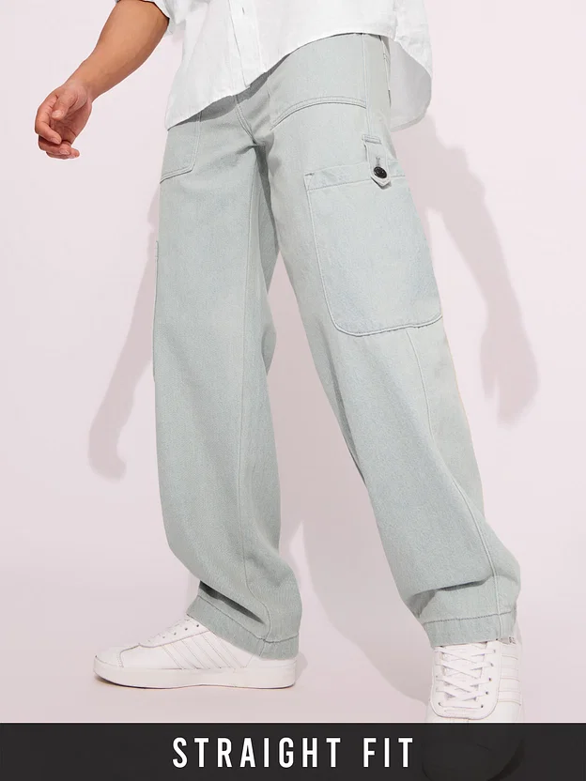

Link: <https://res.cloudinary.com/dvyft9plf/image/upload/v1725693095/baggy_fit_1_y5pz7h.webp>

* + Description
    - Shop for Solids: Light Beige (Straight Fit) at The Souled Store.
  + Material & Care:
    - 96% Cotton 4% Lycra
    - Machine Wash

Category: Shoes

1. Nike Cortez Textile

Images:

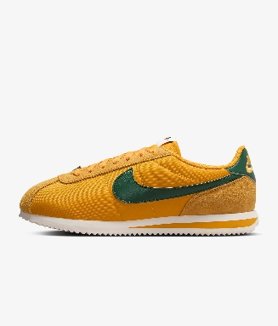 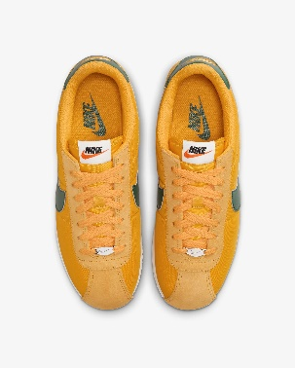 

Link: <https://res.cloudinary.com/dvyft9plf/image/upload/v1725693320/WhatsApp_Image_2024-09-07_at_12.43.30_417fcaab_rkuzxn.jpg>

Description:

- OverView:

- One word: tradition. From heritage running to a fashion phenom, the Cortez's retro appeal, sponge-soft midsole and seesaw detailing deliver decade after decade. This iteration combines ribbon lacing and a monochromatic look for elevated style.

- Benefits

- Textile upper with suede accents provides a comfortable fit that lasts.

- Foam midsole with iconic wedge insert provides lightweight cushioning.

- Herringbone outsole pattern pairs durable traction and heritage style.

- Padded, low-cut collar looks sleek and feels great.

- Product Details

- Colour Shown: Yellow Ochre/Safety Orange/Black/Gorge Green

- Style: DZ2795-702

- Country/Region of Origin: Indonesia

2. Air Jordan 4 RM

* Images:

  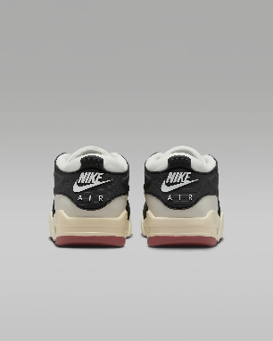

Link: <https://res.cloudinary.com/dvyft9plf/image/upload/v1725693312/WhatsApp_Image_2024-09-07_at_12.43.30_9e08b634_bd617n.jpg>

* OverView
* These sneakers reimagine the instantly recognisable AJ4 for life on the go. We centred comfort and durability while keeping the heritage look you love. Max Air in the heel cushions your every step, and elements of the upper—the wing, eyestay and heel—are blended into a strong, flexible cage that wraps the shoe to add a toughness to your everyday commute.

Benefits

* Genuine leather upper helps provide durability and structure.
* Plush and comfortable, the Max Air cushioning has just the right amount of support.

- Rubber outsole helps provide traction.

- Product details

- Nike Air logo on heel

- Jumpman on tongue and sole

- Colour Shown: Sail/White/Coconut Milk/Black

- Style: FQ7939-100

- Country/Region of Origin: Vietnam

1. Hunter Boots

Images:

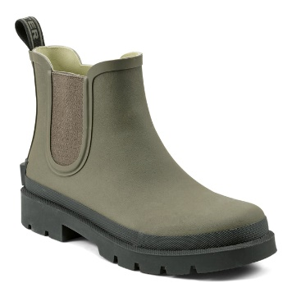 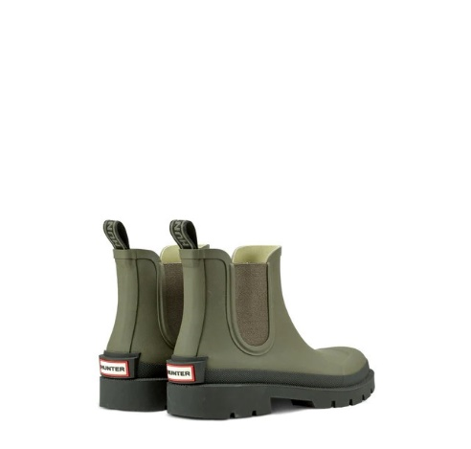

Link: <https://res.cloudinary.com/dvyft9plf/image/upload/v1725693305/WhatsApp_Image_2024-09-07_at_12.43.30_0c629b05_aqzjeb.jpg>

- OverView

- Get the comfiest fit for your rainy day look in the Orford weather boots while still looking stylish. Featuring a slip-on silhouette, comfort footbed and are waterproof to keep you staying dry all day.

- Benefits

- Suede upper creates a classic look that's built to last.

- Vulcanised construction fuses the sole to the upper for a flexible, broken-in feel.

- The solid rubber outsole with herringbone pattern adds durable traction and heritage style.

- Product details

- Colour Shown: Grey

- Style: HF3831-001